
Viet Legend Travel Co.,Ltd
The International Tour Operator License No:0573/2006/VNAT
Tel: (84-8)3 55 310 55 /(84-8)3 601 41 68 Fax: (84-8) 6 2 58 11 68
hotline: (84) 937.73.73.88 –English speaking ( Mrs Darling NGUYEN)
Email: info@vietnamlegendtravel.com Website:www.vietnamlegendtravel.com

Southern Excursions
Trip name: Cai Be Floating Market
Trip code: VLV-81
Trip duration: Full day (tour starts at 07:30 to 16:00)
Trip Operates: Year Round / On Demand
Trip price: Available upon Request
Trip route: Saigon –Cai Be –Vinh Long –Saigon
Starts/Ends trip: HCMC (Saigon)/Saigon
Trip type: Landscape & Culture
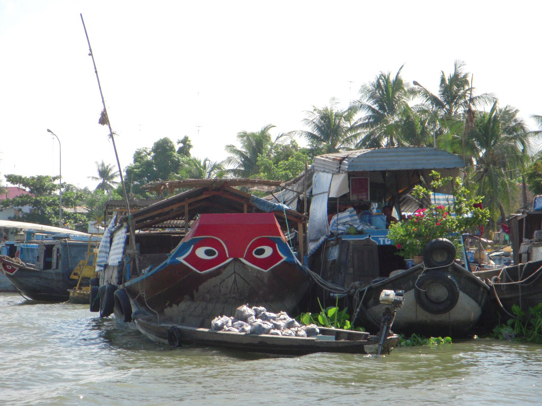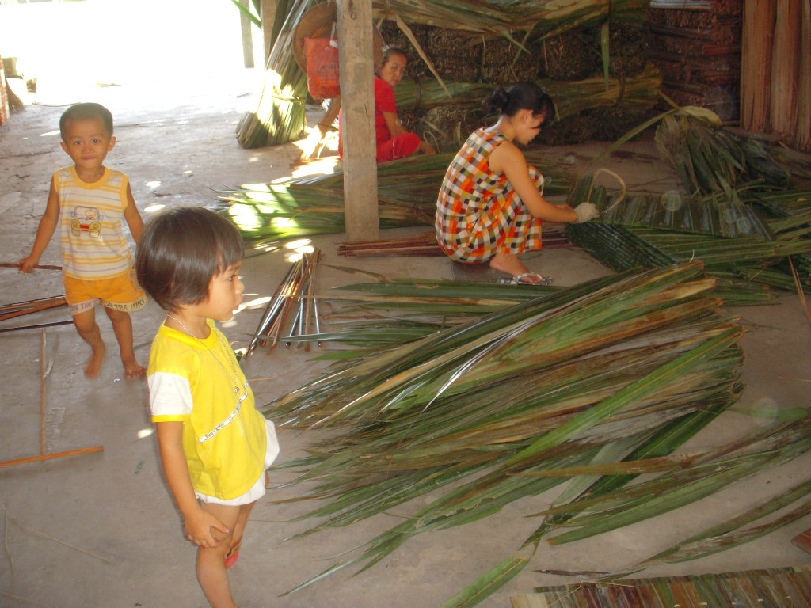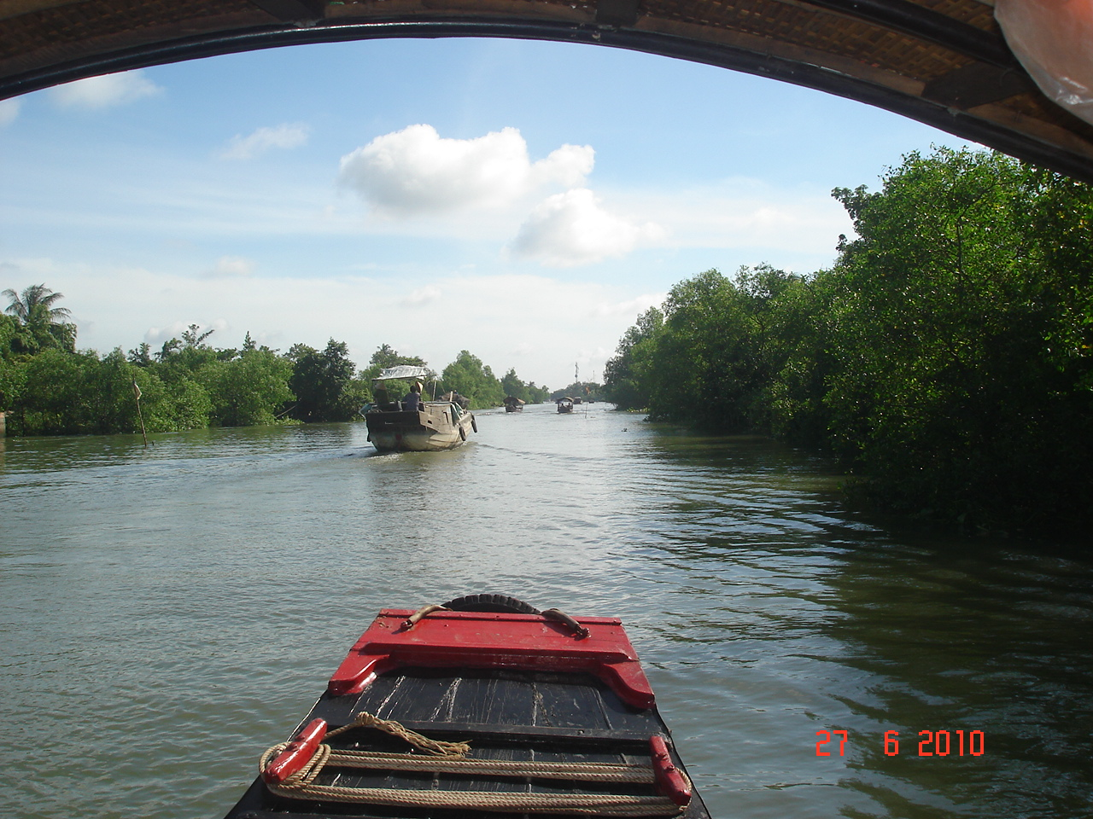

Brief program:
Full day to Cai Be Floating market

Cai Be is a river-land mixed town in Vietnam. It is a district of Tien Giang Province in the Mekong Delta region of Vietnam. Along the river, there are docks that handle passengers and goods, and the floating market. Cái Bè is the north shore of the tree My Thuan Bridge, the gateway to the city of Vinh Long and the Cuu Long River Delta. Cái Bè was a location for the 2009 U.S. television series the Amazing race 15.

Itinerary
At 07:30-08:00 AM, transfer to Cai Be by car. Spend on car 2 hours, we arrival in Cai Be town.
Take boat trip to visit Cai Be colorful floating market cruising among local barges full of fruits and vegetables. Then, an optional stop can be made at local workshops where you can see how rice paste, coconut candy and pop-rice, popcorn is made. It is so interesting to visit the handicraft village, where you can see how they make some special products as: Making rice-net for spring rolls, fish sauce & Soya sauce, cooking salt, sewing coconut-leaves for cottage proof...A delicious lunch will be served at Mr. Kiet an ancient house over 170 years old or under the shade of local orchards on the An Binh Island. After lunch, the rowing boat will take you deeper into the countryside to enjoy the peaceful time on smaller canals. It is so interesting to see traditional houses made of wood and palm tree leaves and see some activities of the local farmers with an opportunity to make contacts with them and see how they catch fish or pick up fruits by ancestral ways in Mekong Delta. Visiting Mr Cai Cuong’s ancient house - landlord’s one in the past, farming tool display, rice planting line- the miniature pictures of the Mekong delta. Enjoy tea with some of the local tropical fruits and listening to the traditional music is the best chance for relaxation. Boating to visit an orchards or a nursery garden .The cruise will end at around 15:30 pm in Vinh Long market for see more local style. Get on vehicles to make our way back to Saigon . End service.

Our Caibe floating market tour includes:
- Services of local drivers and private air-conditioned vehicles during all tours and transfers
- Services of local English speaking guides during all tours and transfers (other language guides available on request with additional fee)
- Admission fees for all sights visited
- Lunch at local restaurant
- Boat cruise
- Services charge & government taxes
Our Caibe floating market tour excludes:
- Optional visits to sights not mentioned in the program
- Surcharge fees in peak season ,national holidays & weekend
- Drinks at mealtimes
- Camera and video cameras fees if applicable
- Compulsory Personal Travel Insurance
- Tips for guide, driver
- Meals other than those mentioned above
- Other services not clearly indicated in the Inclusion Package above
- Bank fees
Our Caibe floating market tour Bonus:
- Drink during the visit : 01 bottle 500mml/pax/day
- Service 24/24 –English speaking of our consultant/tour operator

