
Viet Legend Travel Co.,Ltd
The International Tour Operator License No:0573/2006/VNAT
Tel: (84-8)3 55 310 55 /(84-8)3 601 41 68 Fax: (84-8) 6 2 58 11 68
hotline: (84) 937.73.73.88 –English speaking ( Mrs Darling NGUYEN)
Email: info@vietnamlegendtravel.com Website:www.vietnamlegendtravel.com

MEKONG CRUISE
L’AMANT – LUXURY CRUISES
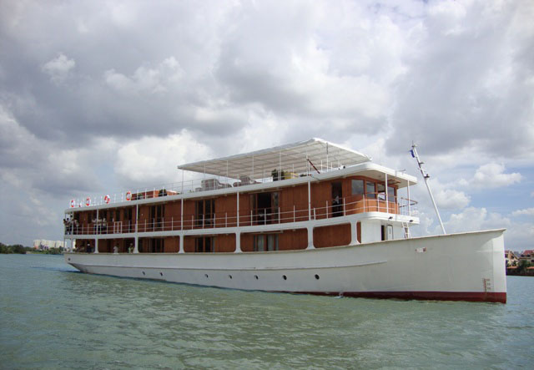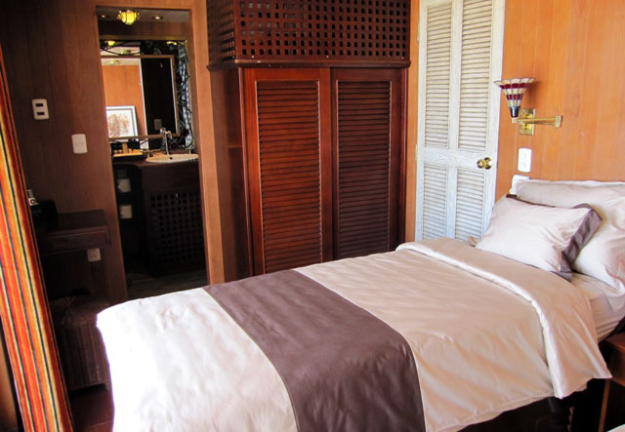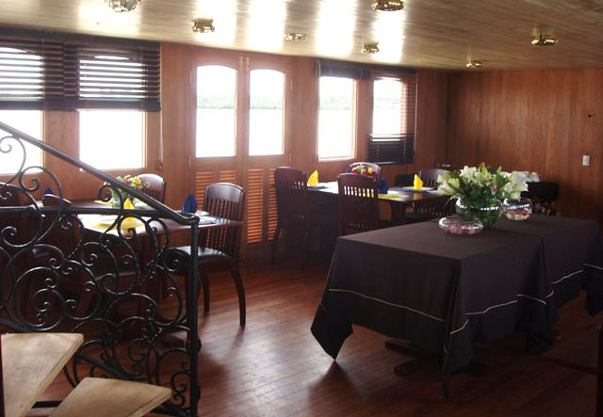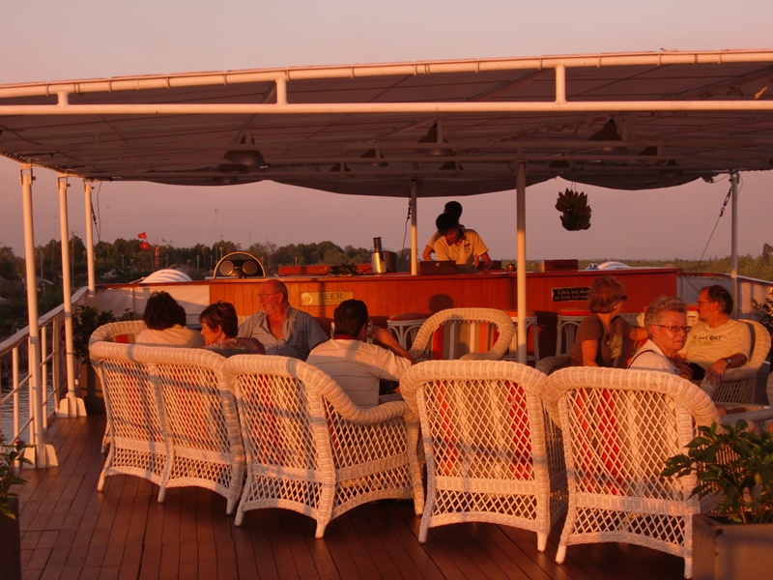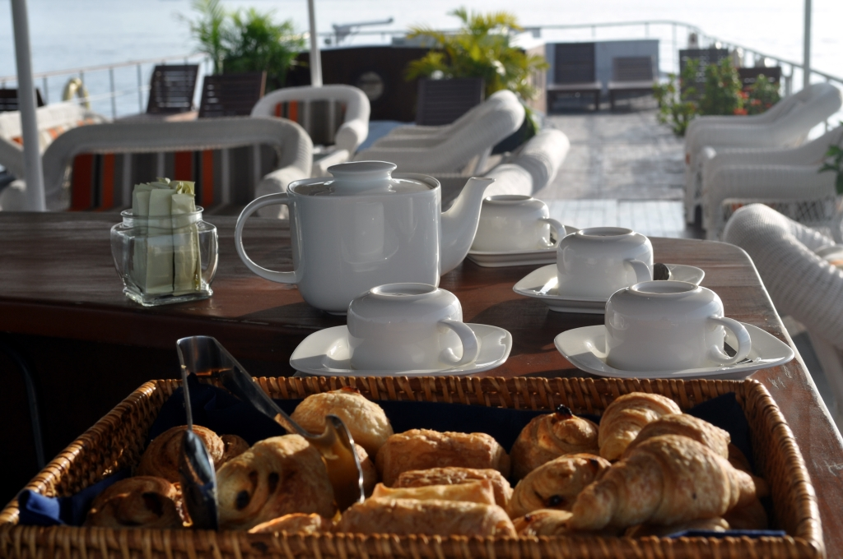
ABOUT CRUISE
L’Amant combines traditional boat-building with modern comfort and can accommodate up to 24 passengers in its 12 cabins to cruise the Mekong in luxury. Measuring 39 m long by 7 m wide, L'Amant cruiser was built in a colonial style. The vessel offers a large restaurant, a bar and a sundeck where passengers will be captivated by the serenity and the beauty of nature throughout the journey.

- Thee days itinerary
Trip name: Saigon-Sadec-Saigon
Trip code: VLV-66 (3D/2N)
Trip duration: 3days/2night
Trip Operates: Year Round / On Demand
Trip price: Available upon Request
Trip route: Saigon-Caibe-Vinhlong-Sadec-Saigon
Starts/Ends trip: Saigon/Seam Reap
Trip type: Nature , landscape & Cruising

Brief program:
Day 1: Saigon-Caibe-Vinhlong -Sadec
Day 2: Sadec-caibe
Day 3: Caibe-Saigon

Day 1:Saigon / Cai be / Vinh long / Sadec (l/d)
Meeting point is at 09h30 at the lobby of the Caravelle Hotel. Coach transfer to Cai Be in the very heart of the Mekong Delta. On arrival, embark on board L’AMANT and enjoy a delectable lunch and get acquainted with the crew, while the vessel starts its way to Vinh Long.
In the early afternoon, embark on a small boat for a journey towards An Binh islands. On arrival, continue the tour by bicycle to visit Tien Chau ancient pagoda and discover the everyday life in the Mekong Delta. Continue to visit a traditional house and enjoy some mouth-watering tropical fruits. Then tour on a small boat along the canals and stop at a fruit garden.
Anchorage near Sa Dec. Welcome dinner and overnight on board of L’AMANT.

Day 2 Sa dec / Cai be (B/L/D)
After breakfast, visit Sa Dec, the old-fashioned town, famous for its flowers and bonsai plants, and where the French Writer Marguerite Duras spent her childhood. Stop to visit the ancient house of Huynh Thuy Le, the “house of the Chinese” described in Marguerite Duras’novel L’Amant, before heading to a Chinese temple and stopping at the tomb of l’amant. Finally, pass-by the school where Margerite’s mother has taught as well as the house where she used to live with her children. On the way back, stroll through the lively market streets of this fascinating town.
Return on board L’AMANT.
In the early afternoon, arrive in Cai Be and embark on a local sampan boat for a journey through the numerous arroyos and be captivated by the serenity of the Mekong Delta. Visit an ancient colonial house and a rice popcorn factory and taste the local specialties. Upon return, enjoy a cooking demonstration on board - an interesting way to learn about the local ingredients and how to cook one of the typical Vietnamese traditional dishes.
Farewell dinner and overnight on board of L’AMANT.

Note: the school is closed during Tet (Vietnamese New Year festival) and other public holidays.

Day 3 Cai be / Saigon (B)
Early breakfast on board (7h00) before checking-out and embarking on a local sampan boat and sail through small arroyos to explore the vibrant Cai Be’s floating market.
After the visit, head back to Ho Chi Minh City by coach. Arrive at Caravelle Hotel at around 12h00.

End of our services.

- Five days itinerary
Trip name: Saigon – My Tho – Sa Dec – Chau Doc
Trip code: VLV-66 (5D/4N)
Trip duration: 4days/4nights
Trip Operates: Year Round / On Demand
Trip price: Available upon Request
Trip route: Saigon-Mytho-Bentre-caibe-Vinhlong-Sadec-Chaudoc-Phnompenh
Starts/Ends trip: Saigon/Seam Reap
Trip type: Nature, landscape & Cruising

Brief program:
Day 1: Saigon-Mytho-Bentre-Caibe
Day 2: Cai Be -Vinh Long- Sa Dec
Day 3: Sadec-near Chau Doc
Day 4: Chau Doc
Day 5: Chau Doc – Phnom Penh

Day 1 Ho Chi Minh City / My Tho / Ben Tre / Cai Be (L/D)
Meeting point is at 10H30 at the lobby of the Caravelle Hotel. Then, drive through to My Tho - the gateway to the Mekong Delta. On arrival, embark on board L’AMANT and enjoy a delectable lunch while getting acquainted with the crew.
In the afternoon, board a river-boat to explore the hidden treasures of the Xep canal and islands, full of tropical fruit gardens. An exciting ride on a carriage drawn by small horses awaits you for a stroll through fascinating farming villages. Enjoy the tasty fruits and tea with natural honey.
Then continue your journey on a sampan boat through the canals before getting back on board of L’AMANT.
Welcome dinner and overnight on board.

Day 2 Cai Be / Vinh Long / Sa Dec (B/L/D)
After breakfast, board a local sampan boat and sail through the canals to explore Cai Be’s vibrant floating market. Along the way, visit a charming ancient colonial house and a handicraft workshop.
Return on board of L’Amant for lunch.
In the early afternoon, embark on a small boat for a journey towards An Binh islands. On arrival, continue the tour by bicycle to visit Tien Chau ancient pagoda and discover the everyday life in the Mekong Delta. Continue to visit a traditional house and enjoy some mouth-watering tropical fruits. Then tour on a small boat along the canals and stop at a fruit garden.
Anchorage near Sa Dec.
Dinner and overnight on board.

Day 3 Sa Dec / Near Chau Doc (B/L/D)
After breakfast, visit Sa Dec, the old-fashioned town, famous for its flowers and bonsai plants, and where the French Writer Marguerite Duras spent her childhood. Stop to visit the ancient house of Huynh Thuy Le, the “house of the Chinese” described in Marguerite Duras’novel L’Amant, before heading to a Chinese temple and stopping at the tomb of l’amant. Finally, pass-by the school where Margerite’s mother has taught as well as the house where she used to live with her children. On the way back, stroll through the lively market streets of this fascinating town.
Return on board for lunch while sailing to Chau Doc. During the afternoon you can enjoy a cooking demonstration or just relax on the sun deck. Anchorage on the way to Chau Doc
Dinner and overnight on board

Day 4 Chau Doc (B/L/D)
In the morning, you will reach the city of Chau Doc, the border city with Cambodia. Visit a floating fishing farm where thousands of fishes are breed for export and visit a mosque in a Cham village. In the afternoon, visit Sam Mountain, a popular pilgrimage site where you will find a large number of Chinese, Cham and Khmer temples.
Farewell dinner and overnight on board.

Day 5 Chau Doc – Phnom Penh (B)
After breakfast, disembark and depart to the Cambodian border by a speed boat, go through the customs formalities and continue your cruise to Phnom Penh arriving by early afternoon.

End of our services.

- PRICES
Children Policy:
Children below 4 years old can share the cabin with their parents without extra charge but baby cot
is not available (no extra bedding).
Children from 4 to 12 years old must solely occupy a berth with 30% discount from adult tariff.

Cruise Price includes:
- Cruise 3 days / 2 nights – Saigon - Sa Dec - Saigon
Transfer from Saigon to the port of embarkation in Cai Be by coach.
Return from Cai Be to Saigon by coach.
Accommodation in single/double cabin with full board meals as mentioned on the program (breakfast/
lunch/dinner).
English or French speaking guide.
All visits and excursions mentioned.
- Cruise 5 days / 4 nights – Saigon – My Tho - Sa Dec – Chau Doc
Transfer from Saigon to the port of embarkation in My Tho by coach.
Transfer OUT / from Chau Doc to Phom Phenh by speed boat.
Accommodation in single/double cabin with full board meals (breakfast/lunch/dinner).
English or French speaking guide.
All visits and excursions mentioned.
Port dues.

Cruise Price Excludes:
Visas fees - Laundry - Drinks - Fuel surcharge - Tips to crew - Other personal expenses - Government tax -
International flights and airport taxes - Insurances - VAT at 10%

Cabin & fertilities
The boat features 12 double cabins of 16 m² each, equipped and decorated in a delicate style. All the cabins are fitted with a wardrobe, a centralised individually controlled air-conditioning, a private balcony,
a large glass sliding door dressed with curtains, a bathroom with toilets, shower and hair-dryer.
All equiped with 220V sockets.
The restaurant offers buffets and à la carte gourmet menus in an elegant atmosphere. The wine list will please the amateurs and delight the connoisseurs with its outstanding selections of grand cru.

On board activities
L’Amant proposes exceptional services for an unequaled cruising experience, sailing from the Mekong Delta to the white sandy beaches of the Gulf of Thailand. Along this unique journey, you will discover the authentic life of the Mekong region inhabitants and unveil its colorful sceneries.

